Practice Test 1

Calculator Free Section

Name: _______________________ Score: _____ / 18

No calculators or notes are to be used.
Mathematics Specialist Formula Sheet is permitted
Time limit = 20 minutes

1. (4 marks)
Given that z is a complex number solve , giving the solution(s) exactly in the form a + bi.

2. (3 marks)

Rewrite $\left\{z:\left|z-\left(2+4i\right)\right|=\left|z-1\right|\right\}$ as a cartesian equation.

3. (3,3 = 6 marks)

a) Given $z=a-3i$ and $z+c\overline{z}=12+6i$, determine $a$ and $c$.

b) Given $w=bcis\frac{5π}{6}$ and $\left|{\left(\overline{w}\right)}^{3}\right|=0.001$, determine $b$

and give the principal argument of $w^{3}$.

4. (5 marks)

Use De Moivre's Theorem to find all the roots of z⁴ = -8 + 8√3i. Give your answers exactly in polar form, with r >0 and .

End of Section One

Practice Test 1

Calculator Assumed Section

Name: _______________________ Score: _____ / 29

Calculators allowed and one double-sided page of A4 notes.
Mathematics Specialist Formula Sheet is permitted
Time limit = 30 minutes

5. (2,2,2,2 marks)

Suppose that z is a complex number with modulus r and argument θ.
Express in terms of r and θ the modulus and argument of each of the
four complex numbers z₁, z₂, z₃, and z₄ where

( i ) z₁ = z²

( ii ) z₂ = 2z

( iii ) z₃ = z⁻¹

( iv ) z₄ = -iz

6. (2,2,2 marks)

The complex numbers of z and w are such that:

z = 3cis( ) and w = cis( )

Determine the following.

a) z + w (in a + bi form)

b) wz (in cis form)

c) $\frac{1}{\overline{z}}$ (in cis form and a + bi form)

7. (5,5 marks)

a) On the Argand Diagram below, sketch and label both of the sets of points specified:

i) ii)

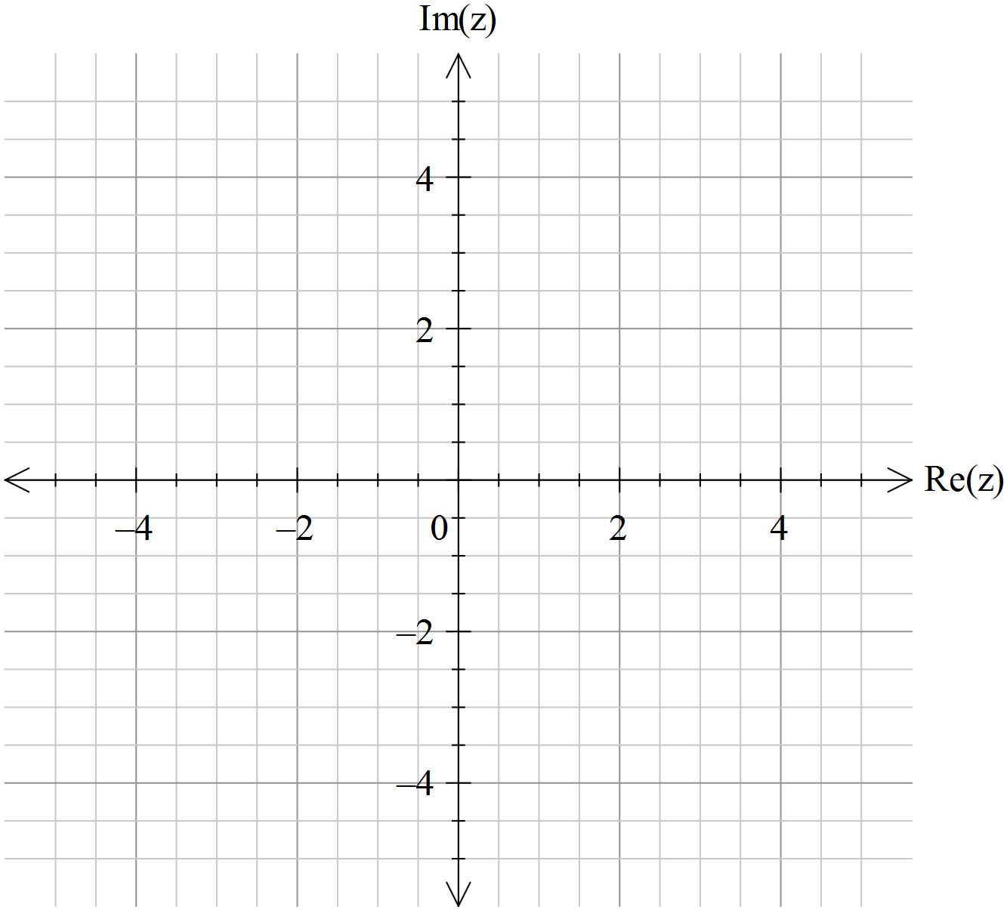

b) Determine to four decimal places the largest possible argument, , of the complex number that satisfies

8. (4,1 marks)
a) Use de Moivre’s theorem to show that $\cos{4x}=\cos^{4}{x}+\sin^{4}{x}-6\cos^{2}{x}\sin^{2}{x}$

b) Use this result to show that $\cos{4x}=1-8\cos^{2}{x}\sin^{2}{x}$

End of Test

